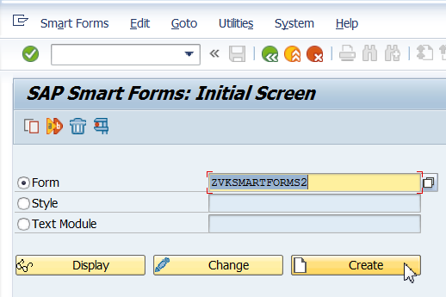

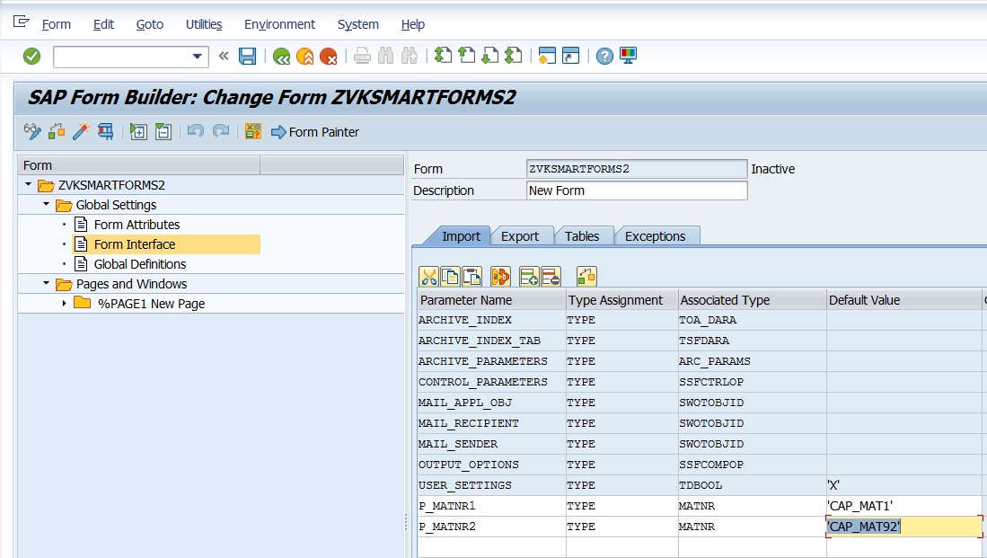

Note: GO to SE11 P_MATNR1 and P_MATNR2 that can be given as Default Value here.

Create Global Definitions as shown below.

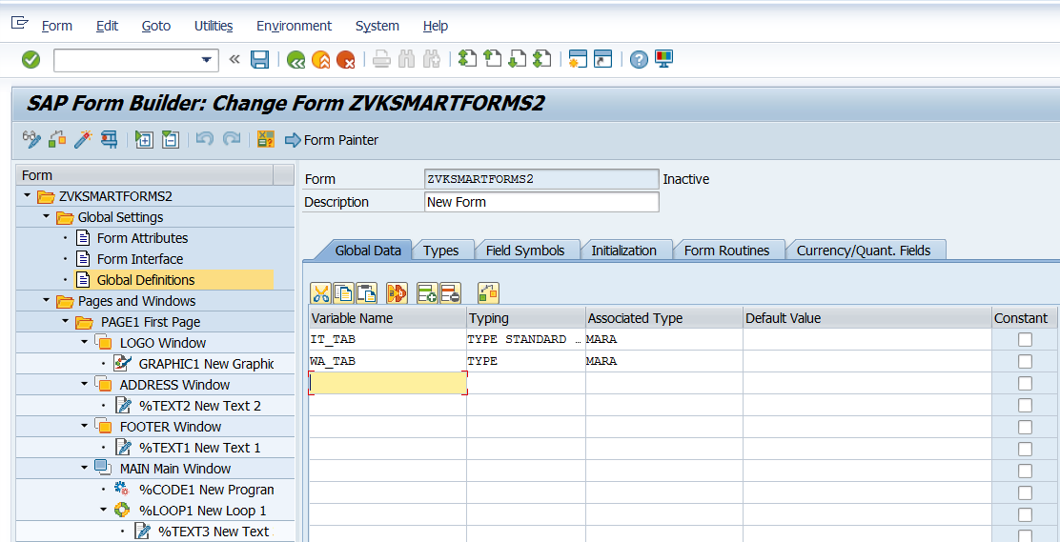

Give Page Name and Next Page as shown below.

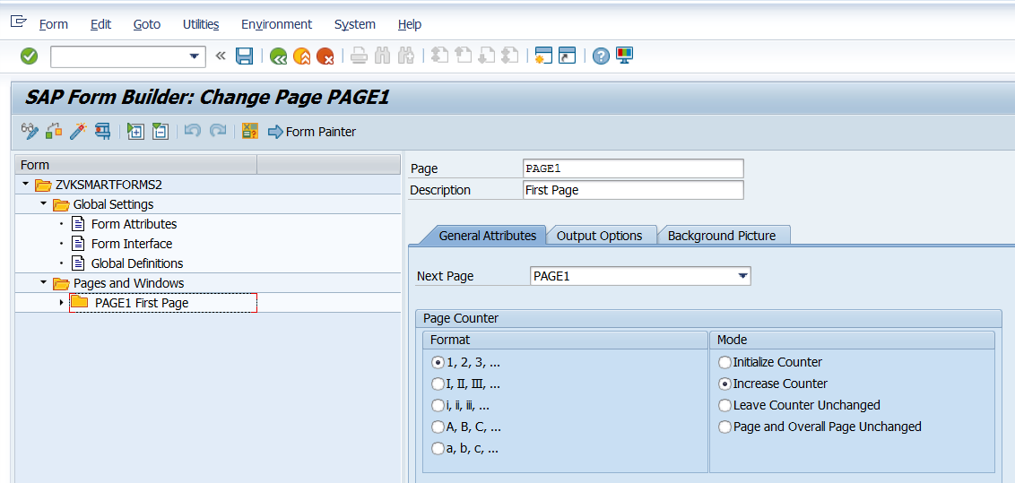

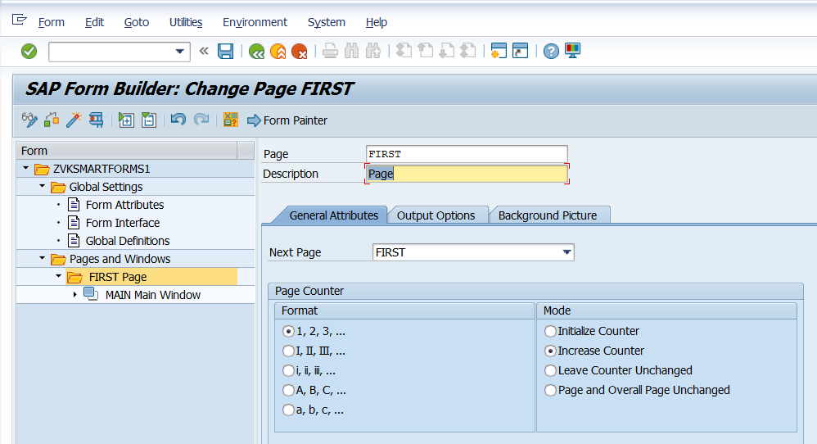

Create three Windows in PAGE1 as shown below.

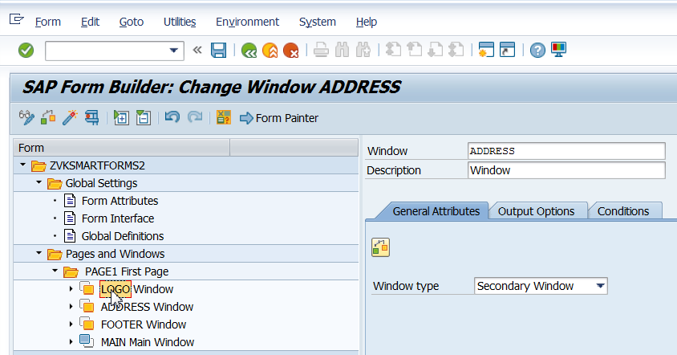

Click on Form Painter and place windows position and size appropriately. Zoom in and out as per the requirement. Click on Form Painter again to toggle it off.

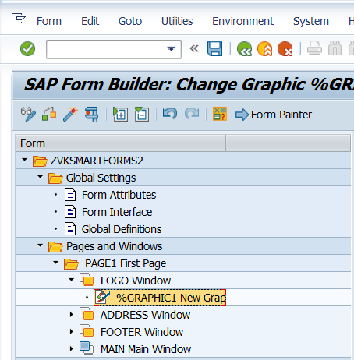

Right Click on LOGO window and create a new graphic.

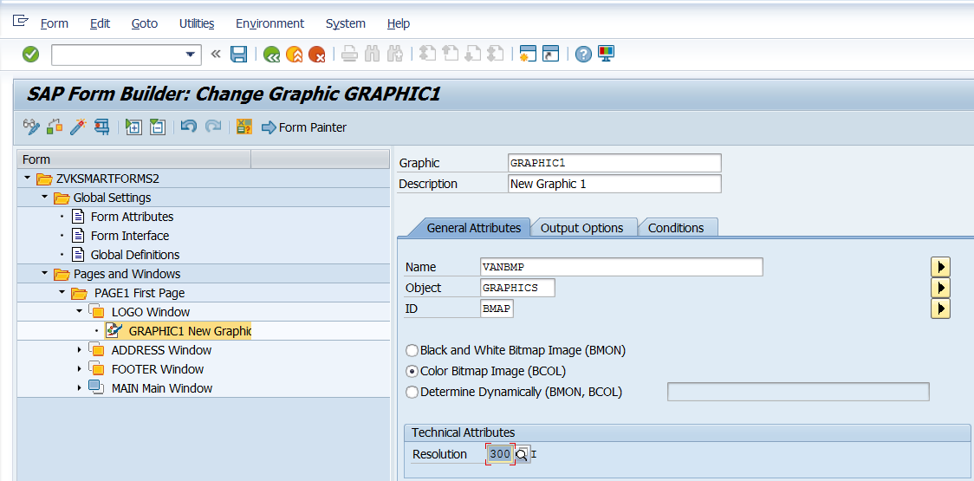

Right Click on Footer to create a Text Element.

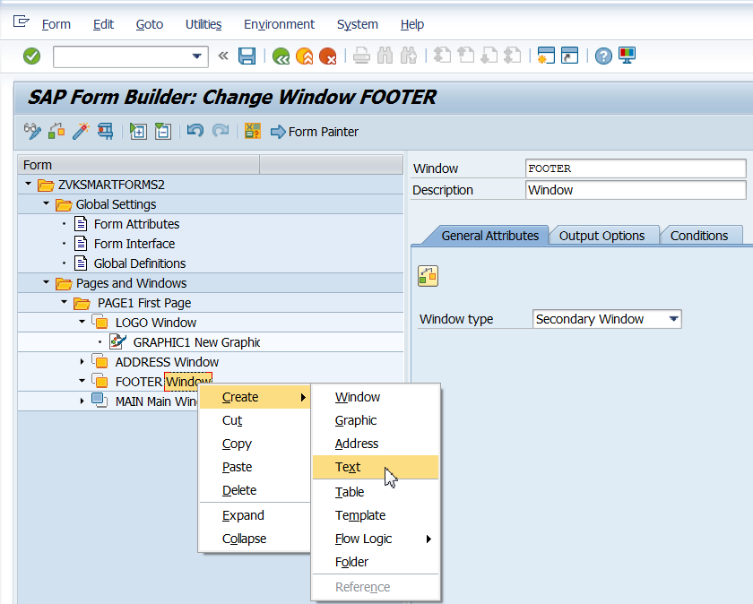

Click on field list on/off to see the field list

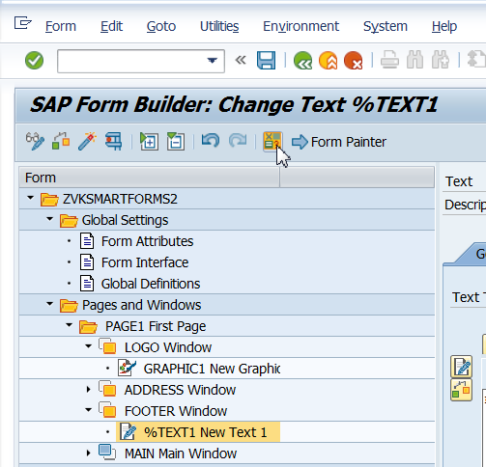

Drag and drop date. Backspace key left arrow key takes you to the beginning of the system field where you can type Date:. Alternatively, you can first type Date: and then drag and drop the system field.

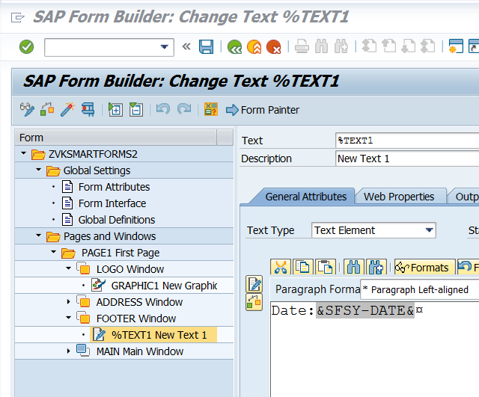

Press spacebar. Type Time: Drag System Field.

Press spacebar Type Page No: Drag System Field.

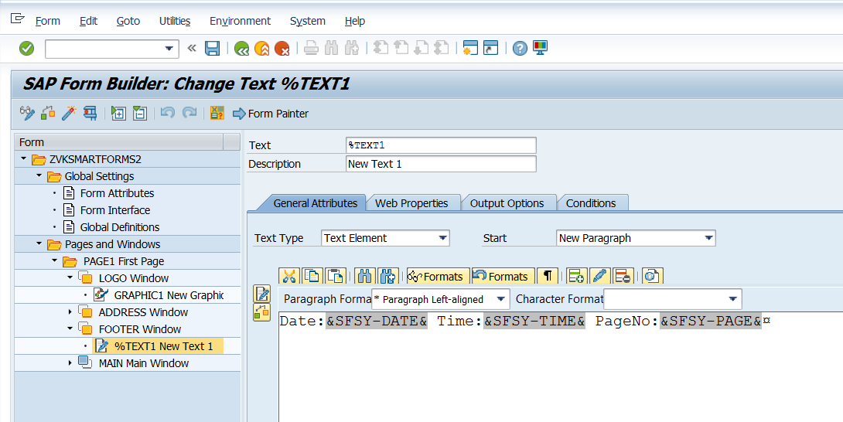

Create a Text in the address window and type as shown below.

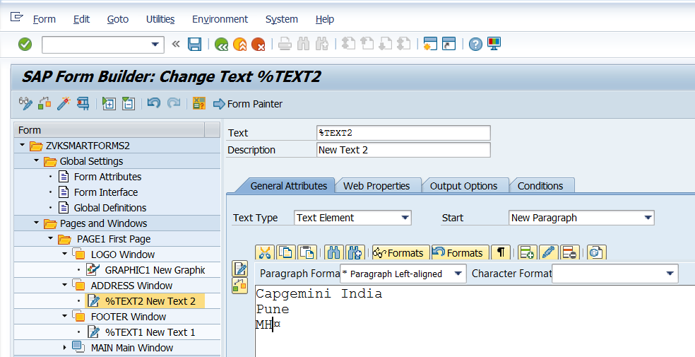

Right Click on Main Window and create program lines.

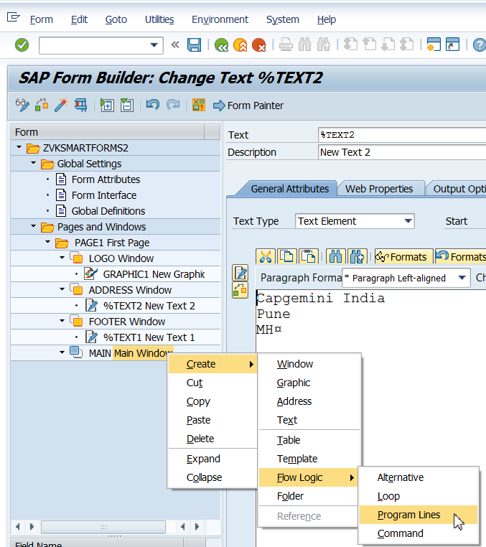

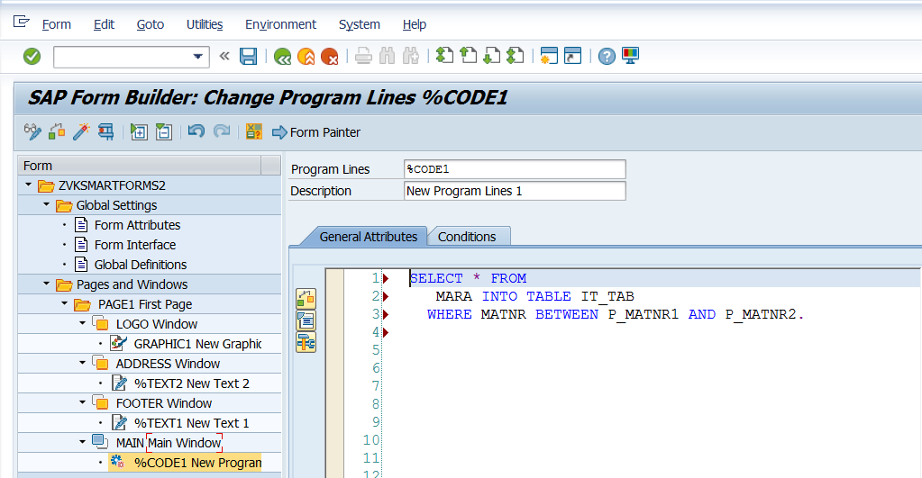

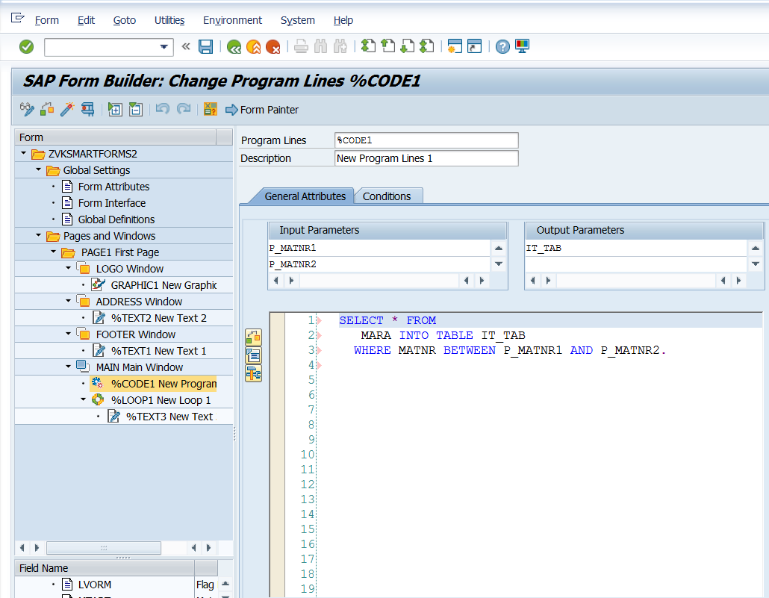

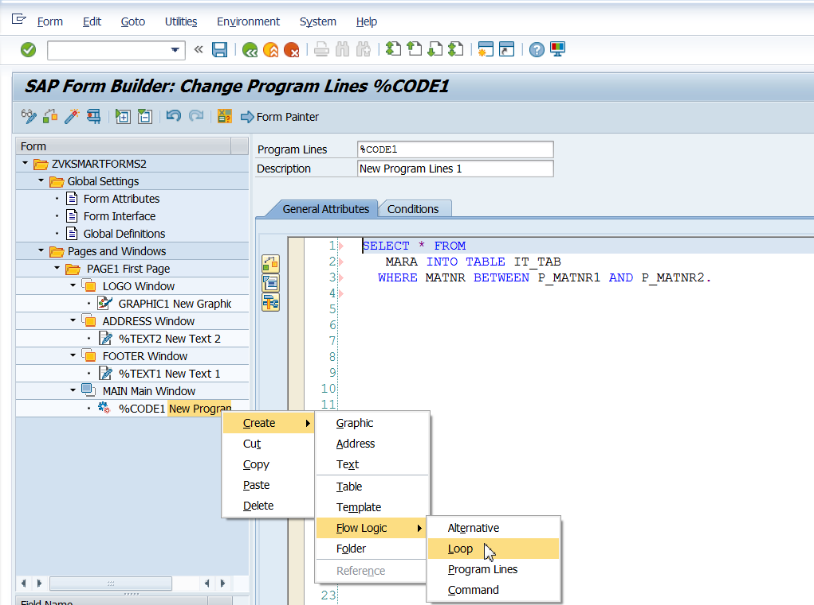

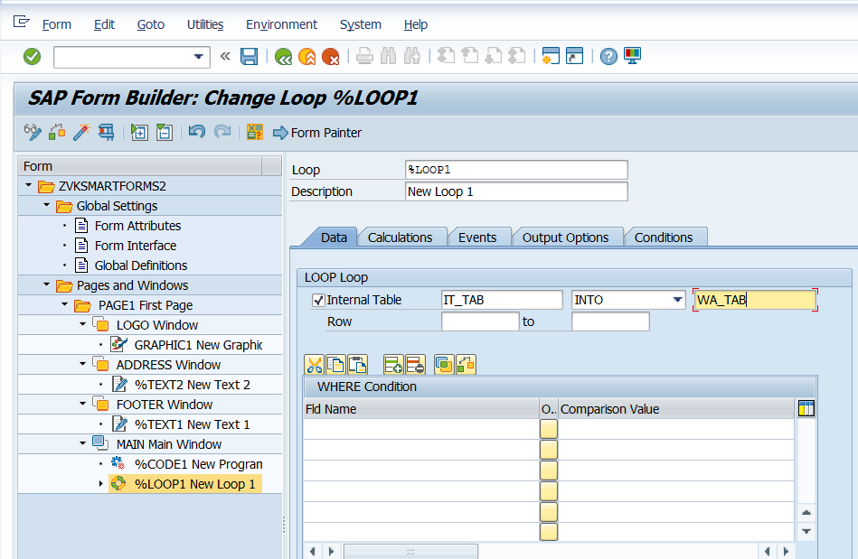

Create Text Inside the loop.

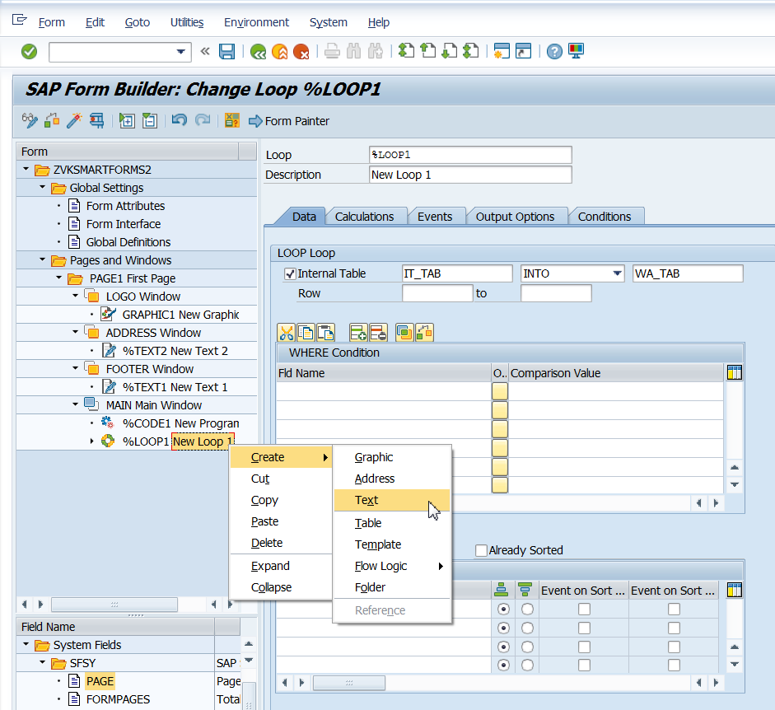

Drag Fields from the Field List and Prefix with Labels as shown below:

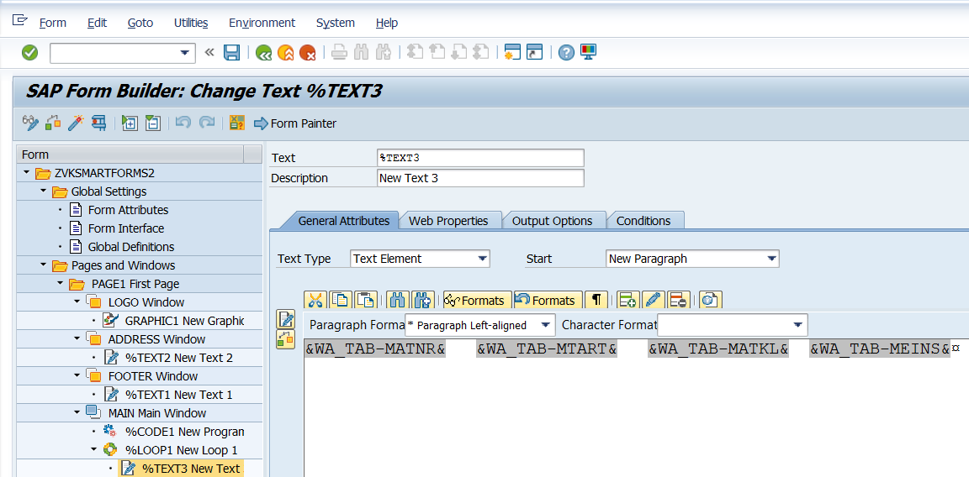

Save, Activate and execute.

Footer is visible on both pages. So is the Logo.

Choose to display logo only on the First Page.

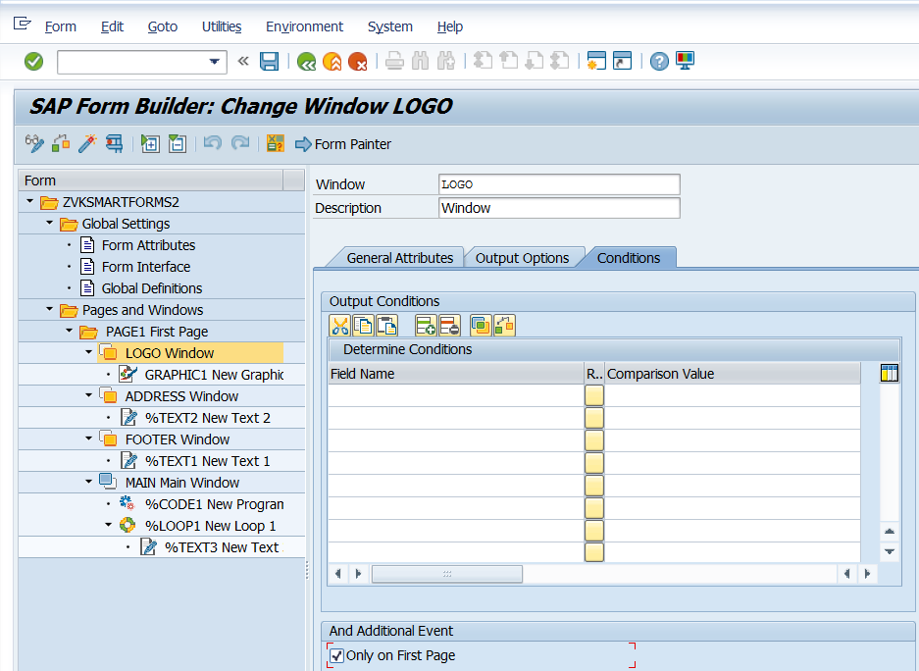

Observe: Code will be put first to get the data and then the loop will be put.